Implement the concept given in below blog link and share the complete steps along with screenshots.



We will now start HBase shell and create a table.

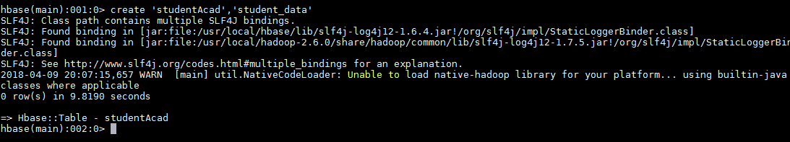

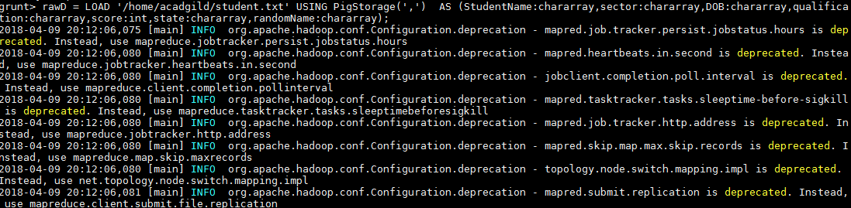

Now we can transfer the data inside HBase by STORE command.

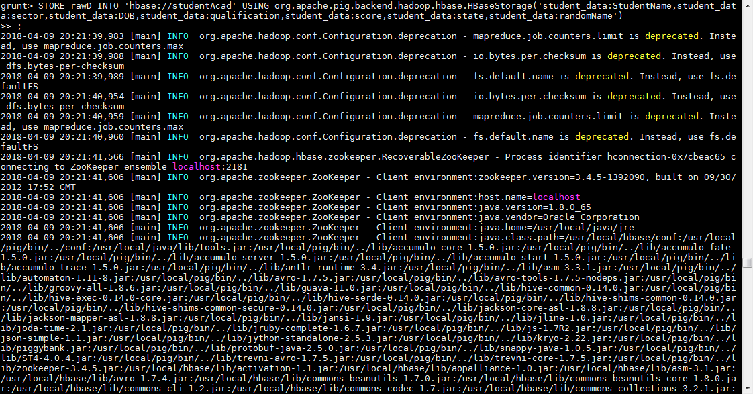

Once the success message comes as shown below , it is confirmed our data is loaded inside HBase.

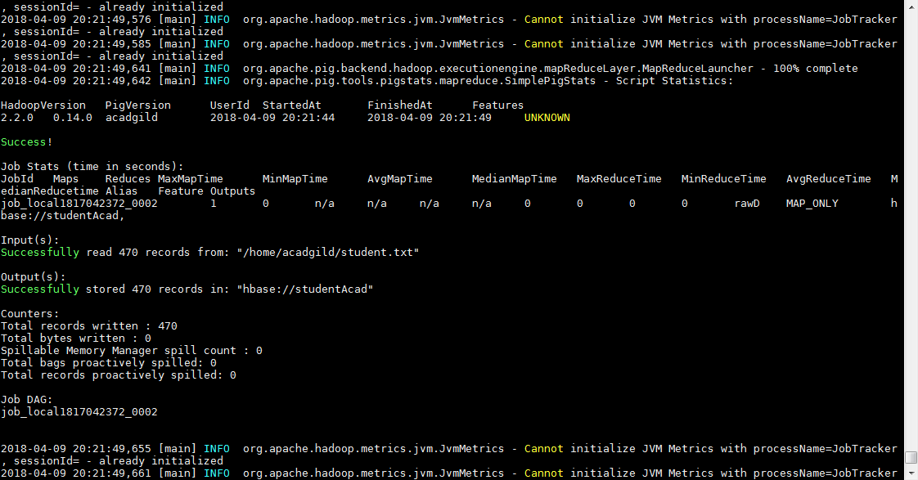

The result can be displayed through scan command followed by table name inside quotes( ‘ ‘ )

